**A Mini Project Report on**

**‘COMMEMT CLASSIFICATION ’**

**Submitted By**

**Tejas A Sonkule (CETSYB6-70).**

**Gaurav G Medhne (CETSYB6-56).**

**Utkarsh .P. Kamble (CETSYB6-73).**

A Project report submitted as a partial fulfillment towards Practical of Applied Mathematics for semester III of S. Y. B. Tech. (‘School of computer and technology’)

2018-19

Under the guidance of

**A S Sonwane**

School of Computer Engineering & Technology

MIT Academy of Engineering, Alandi (D), Pune-412 105

**C E R T I F I C A T E**

*This is to certify that* ***Tejas.A.Sonkule(CETSYB6-70),Gaurav.G.Medhne(CETSYB6-56),Utkarsh.P.Kamble(CETSYB6-73)*** *of MIT Academy of Engineering, Alandi (D), Pune have submitted Minor Project report on “***‘COMMEMT CLASSIFICATION’***” as a partial fulfillment of Semester-III and Semester IV S. Y. B. Tech. for completion of Minor work during the academic year 2018-19.*

A S Sonwane

**Name of Instructor Mrs. Prabha Kasliwal**

**(Guide) (Dean, SHES)**

**External Examiner**

**ACKNOWLEDGEMENT**

We take this opportunity to record our profound gratitude and indebtedness to A S Sonwane Assistant Professor, for their inspiring guidance, valuable advices, constant encouragement and untiring supervision throughout our project work.

We express our deep sense of gratitude to Mrs. Prabha Kasliwal Dean, School of Computer Engineering and Technology, for her continuous inspiration and encouragement.

Finally, we would like to acknowledge and express our special thanks to our family, friends and classmates for their patience, encouragement, support they have made during the period of this work.

**Name of Students**

**Tejas A Sonkule (CETSYB6-70).**

**Gaurav J Medhane (CETSYB6-56).**

**Utkarsh .P. Kamble (CETSYB6-73).**

**INDEX**

List of Figures …………………………………………………………………….. *5*

List of Tables ……………………………………………………………………...  *6*

Abstract …………………………………………………………………………… 7

CHAPTER 1 INTRODUCTION ……………………………………………. 8

### Problem Definition

* 1. Purpose
  2. Scope
  3. Abbreviation
  4. Overall Description

CHAPTER 2 SPECIFIC REQUIREMENTS ……………………………….

2.1 Functional Requirements

2.2 Performance Requirements

CHAPTER 3 LITERATURE SURVEY ……………………………………

CHAPTER 4 FEASIBILITY STUDY …………………………

4.1 Social Study

4.2 Economic Study

CHAPTER 5 REQUIREMENTS …………………………………………………….

CHAPTER 6 DATA COLLECTION ……………………………………………….

CHAPTER 7 INDENTIFICATION OF APPROACHES TO SOLVETHE PROBLEM……………………………………………………………..

CHAPTER 8 SELECTION OF APPROACHES……………………………….

CHAPTER 9 USE CASE……………………………….

REFERENCES *………………………………………………………………………………………*

**ABSTRACTCHAPTER 1: INTRODUCTION**

**Problem Definition**

This software is use to classification of comments into negative positive and neutral user is able to classify the comments and identify the reaction of the user for particular product or service. Post their thought and idea about particular topic they want or post information about particular topic. The main purpose of the software to is to check the reaction of the user for the product and service.

**Purpose**

The purpose of this report document is to provide a detailed overview of our software product, its parameters and goals. This document describes the project's target audience and its user interface, hardware and software requirements. It defines how our client, team and audience see the product and its functionality.

**Scope**

This site provides platform to anybody across the globe to classify the comments. It focuses on the user, and applications, which allow for write the comments and classify the comments.

**Abbreviations**

|  |  |
| --- | --- |
| FRU | Function requirement user . |
| FRP | Function requirement admin. |

**Overall Description:**

This Software is about comment classification software using natural processing language. In this software there is a forum where user can enter its comments about the product or service with submit button. After that comment is classify according to the category positive, negative, neutral.due to which admin is able to understand the reaction of the user to the product or service.

**CHAPTER 2: SPECIFIC REQUIREMENTS**

**Functional Requirement**:

1. User Work

|  |  |  |
| --- | --- | --- |
| ID | NAME | DESCRIPTION |
| FRU1 | Enter text | User should enter its comment on the comment box. |
| FRU2 | Submit | After entering the text user must push the submit button in order to publish its comment. |

2. Admin work

|  |  |  |
| --- | --- | --- |
| FRA1 | Classify the comment | Admin should able to classify comments |
| FRA2 | Display comment | Admin should able to display classified comments. |

**Performance Requirements:**

The product is not be based on web therefore internet is not required to run from a web server.

The performance shall depend upon hardware components of the client/customer.

**CHAPTER 3: LITERATURE SURVEY**

Research Paper Name:

AN IMPROVED METHOD OF EXTRACTING EMOTIONAL ATTRIBUTE OF RELATIONS BASED ON SYNTACTICAL ANALYSIS.

AUTHOR: - Jun Wang, Lei Li1, Fuji Ren

RESEARCH PAPER NAME:-

Syntactic Analyzer using Morphological Process for a Given Text in Natural Language for Sense Disambig

AUTHOR: - Gauri Dhopavkar Research Scholar, CSE dept., GHRCE Faculty, CT dept., YCCE

Manali Kshirsagar VP (Academy), ADCC Infocad Pvt.Ltd. Professor, CT dept., YCCE

RESEARCH PAPER NAME :-Syntactic Text Analysis Without a Dictionary

AUTHOR:-

Bessmertny I. A., Professor ITMO University Saint Petersburg, Russian Federation

Platonov A.V., Postgraduate Student ITMO University Saint Petersburg, Russian Federation

Poleschuk E.A., Postgraduate Student ITMO University Saint Petersburg, Russian Federation

Ma Pengyu, Postgraduate Student ITMO University Saint Petersburg, Russian Federation

RESEARCH PAPER NAME

Sentiment analysis in a cross media analysis

Author : yonas woldemarian

RESEARCH PAPER NAME

Applying words vector for sentiment analysis of App reviews.

Author: Xian fan

RESEARCH PAPER NAME

Entity level sentiment analysis of issue comments

Author: jim ding ,xu want.

**CHAPTER 4: FEASIBILITY STUDY**

Social Feasibility:-

It may be affect social media because any comment can be classify as negative positive or neutral.

Economic Feasibility:-

Due to comment classification many company can able to track customer response on there product and make changes according to the result and eventually make profit which effect there economy.

**CHAPTER 5: REQUIREMENTS**

Hardware Requirement:-

Hard disk 1 TB

4 GB RAM

Software Requirement:-

Python 3.6

**CHAPTER 6: DATA COLLECTION**

Primary data:

Data collected from customer in the form of comments, feedback

Etc

Secondary data:-

Data collected by the developer to compare the primary data with secondary data to classify the comment in Positive, Neutral, Negative

**CHAPTER 7: INDENTIFICATION OF APPROACHES TO SOLVE THE PROBLEM**

Text classification:

Text classification is the process of categories to text according to its content.

NPL

NPL is AI method of communicating with an intelligent systems using a natural language such as English.

Sentence analysis in NPL

Analysis will go through your text and identify all of the important word

Sentiment Analysis  
  
   
Token Association  
  
  
Pragmatic Analysis  
  
  
Syntactic Analysis  
  
   
Token Analysis

**CHAPTER 8: SELECTION APPROACH**

We have selected the NPL

NPL involves computers to perform useful tasks with the natural languages humans use.

Sentiment analysis:

 Sentiment analysis provides insight into the real mood behind the messages

Syntactic analysis:

We also need to consider rules of grammar in order to define the logical meaning as well as correctness of the sentences**.**

**CHAPTER 9: USE CASE**

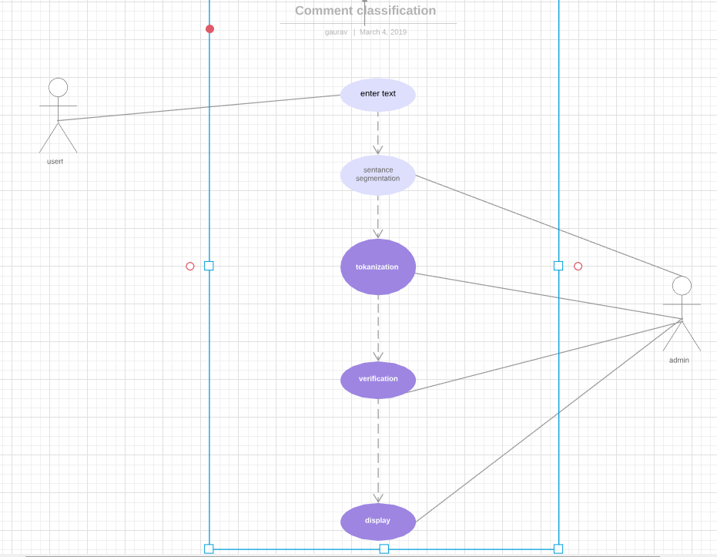

**REFERENCES**